Software Requirement Document
Project Name: Xin1 Integrated Powertrain Domain Controller
Technology Owner:
Version: 1.0
Document No: Xin1_SRS_001

Change History
Version | Date | Author | Reviewer | Approver | Change description
001 | 28/07/2026 | Ratneswar Sahoo | Pankaj D | Rajiv Kumar | Initial Draft

TABLE OF CONTENTS
1 Introduction 4
1.1 Document Scope 4
1.2 Requirements Definition 4
1.3 Terminologies 4
2 Project Requirements 5
2.1 Purpose 5
2.2 Feature List 5
3 System Description 7
3.1 Introduction 7
3.2 Vehicle System Overview 7
3.3 Block Diagram 8
3.4 ECU Interface 8
4 Embedded Software Requirements: 8
4.1 Design Requirements 8
4.2 Diagnostics Requirements 9
4.3 Functional Safety (FuSa) and Cyber Security Requirements 9
4.4 Validation Requirements 9
5 User Interface Requirement 9
6 Considerations/Constraints (SW) 9
7 Other Requirements 9
7.1 Resource Consumption Requirements 9
7.2 Performance Requirements 10
7.3 Operating System Requirements 10
7.4 Project Timeline 10
7.5 Calibration & Code Flashing Sequence 10
7.6 Patches and Updates 11
8 Software Requirements Signoff Details 11
9 Appendix 11

Introduction

Document Scope
The purpose of this document is to define the software requirements for the Xin1 Integrated Powertrain Unit Application Software.
The software shall:
- Manage vehicle operational states.
- Coordinate propulsion control.
- Coordinate steering auxiliary inverter operation.
- Coordinate brake compressor inverter operation.
- Supervise DCDC converters.
- Manage charging communication.
- Perform diagnostics.
- Implement functional safety mechanisms.
- Implement cybersecurity functions.

Requirements Definition
The interpretation of different requirements is controlled by the following definitions:
- Shall, Must - A binding requirement (verifiable) of the component within the scope of this specification.
- Should – A non-binding requirement (recommendation) of the component within the scope of this specification.
- Will - A requirement that is implemented outside of the scope of this specification, that is required for the successful implementation of this specification.
- May – This word in the text expresses a permissible practice or action. It does not express a requirement of the specification

Terminologies
Acronym | Definition
Table 1: Terminologies

Project Requirements

Purpose
The Xin1 Integrated Powertrain Unit shall integrate propulsion control, auxiliary motor drive control, low-voltage power generation and vehicle control functions within a single enclosure.
The Xin1 system shall:
- Convert HV battery energy into traction power.
- Supply regulated LV power to vehicle loads.
- Control steering pump motor operation.
- Control brake compressor motor operation.
- Coordinate propulsion and regenerative braking.
- Support EV charging communication.
- Ensure functional safety and diagnostic functionality.
- Support commercial vehicle applications including HCV, ILM and Bus variants.

Feature List

Stakeholders Description
The following table contains details of all project stakeholders:
Sr.no | Function | Name | Designation
1 | System Engineering |  | System Architect
2 | Functional Safety |  | FuSa Manager
3 | Power Electronics |  | Technical Lead
4 | Software Development |  | SW Architect
5 | Hardware Development |  | HW Architect
6 | Validation |  | Test Manager
7 | Program Management |  | Project Manager
8 | Integration
Stakeholder details

List of features / Broad vehicle level requirements
The given table below contains the list of required features / vehicle level requirements / Applicable PAT requirements.
Veh_REQ_ID | Vehicle Level Requirement / PAT requirement | Remarks
Veh_REQ_01
List of Relevant PAT feature List

Reference documents

System Requirement Document

System Architecture Design Document

Reference of standards/regulations
Document Number | Definition
ISO 26262 | Functional Safety
ISO 21434 | Cybersecurity
ASPICE v4.0 | Software Development Process
AUTOSAR | Software Architecture
ISO 15118 | Charging Communication
IEC 61851 | Charging Interface
UNECE R155 | Cybersecurity
UNECE R156 | Software Update
List of standards

System Description

Introduction
The Software controls and supervises all Xin1 aggregates.
Major software functions include:
- Vehicle State Manager
- Torque Coordinator
- Energy Management
- DCDC Supervisor
- Steering Inverter Control Manager
- Brake Inverter Control Manager
- Charging Manager
- Diagnostics Manager
- Safety Manager
- Cybersecurity Manager

Vehicle System Overview
The software executes on:
- Main CPU
- Sub CPU
The software communicates with:
- Traction Inverter-1
- Traction Inverter-2
- Steering Inverter
- Brake Inverter
- DCDC #1
- DCDC #2
- DCDC #3
- HVIL
- PLC Interface
- Vehicle CAN Network

Block Diagram

ECU Interface
Interface ID | Description
SW_IF_01 | CAN Interface
SW_IF_02 | Internal CAN
SW_IF_03 | PLC Interface
SW_IF_04 | HVIL Interface
SW_IF_05 | Analog Input Interface
SW_IF_06 | Digital Input Interface
SW_IF_07 | HSD Interface
SW_IF_08 | LSD Interface

Embedded Software Requirements:

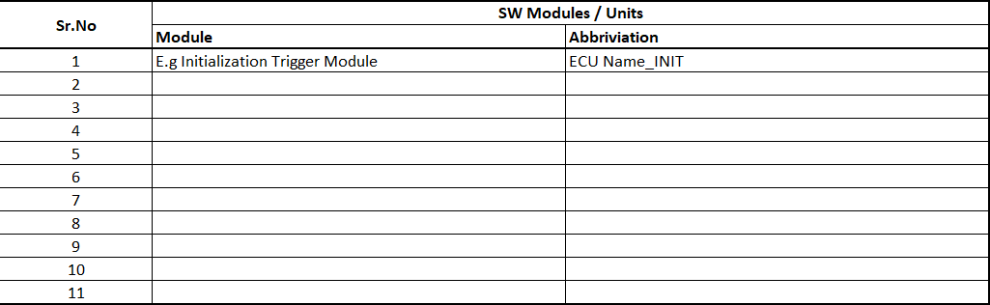

Design Requirements
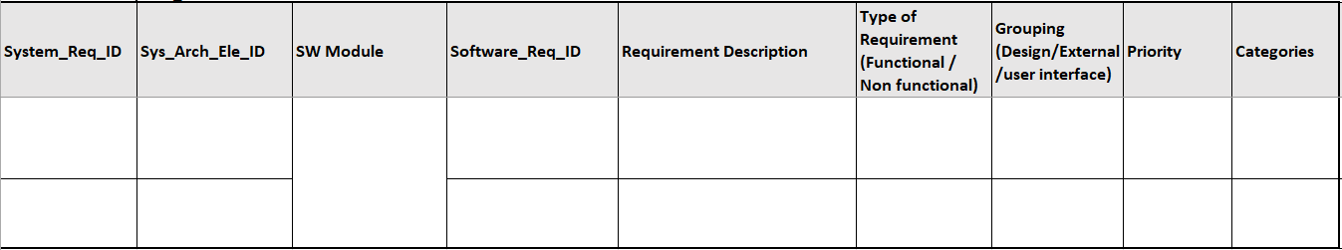
Software_Req_Document

Diagnostics Requirements
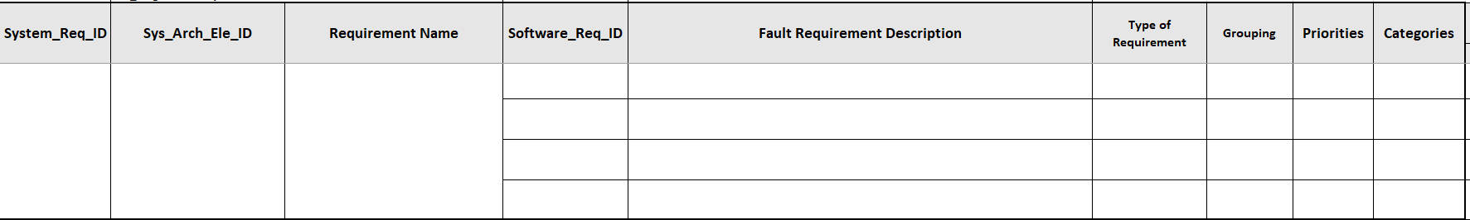
SW_Diagnostics_Req_Doc

Functional Safety (FuSa) and Cyber Security Requirements

Validation Requirements

MIL Validation
SIL Validation
HIL Validation
Lab car Validation
Vehicle Level Validation

User Interface Requirement

Considerations/Constraints (SW)

Other Requirements

Resource Consumption Requirements
Memory | Consumption objective

Performance Requirements
- Efficiency –
- Compliance –
- Coverage –

Operating System Requirements

Tasks
Sr. No. | Tasks | Time (ms) | Description
1
2

Interrupts
Sr.No. | Interrupt Description | Priority

Project Timeline

Calibration & Code Flashing Sequence

STEP | DESCRIPTION
Calibration and code flashing sequence

Patches and Updates

Software Requirements Signoff Details

Sr.no | Function | Name | Designation
1
2
3
4
Software Requirement Signoff

Appendix

